
  - GOMYCODE
  - GMC School of Technology (Woolf)

Daa’ist Cloud Platform for Architecture Students and Student Clubs
  - Cloud-Based Web System Design
  - Islam Alhallak
  - 2026

Abstract
Daa’ist is a web platform at https://daaist.com for architecture students at the Department of Architecture of Algiers (DAA). It combines a catalogue of course notes, tutorials, past exams and administrative documents with club pages, public event registration and QR attendance passes. Next.js provides the interface and server routes; Supabase supplies authentication, PostgreSQL, Realtime and image storage; Cloudflare R2 stores learning resources. An external API generates wind rose and sun path diagrams.
In October 2026, all 132 tests across nine files passed. TypeScript and the production build also succeeded, as did four anonymous browser checks. ESLint reported 85 errors and 10 warnings. GitHub showed no Actions runs; the local workflow is ignored and untracked. User impact and load capacity have not yet been measured.

1. Introduction and problem statement
I experienced difficulty finding and obtaining official student documents that should have been accessible for my studies. Course resources shared through separate channels created a similar problem. Daa’ist addresses these needs through a departmental collection organised by study year and subject. This motivation comes from my own experience; I have not surveyed the department.
The design addresses four needs:
- Discoverability: organise resources so students can locate a relevant year and subject without searching a conversation history.
- Continuity: retain a departmental collection as individual students graduate.
- Access control: separate account, publishing and event-management capabilities, and restrict access to participant information.
- Club operations: connect event information, registration and attendance within one workflow.
The application is maintained by the Archibénévoles student club. It brings the department’s resource catalogue and the club’s day-to-day work into one place. The aim is to make resources easier to find and club administration less scattered; neither effect has been measured yet.

2. Literature review
Prior studies describe how students share course material through messaging groups and the barriers they meet on institutional platforms. They do not test whether a dedicated platform improves learning, so this project treats easier retrieval and continued club participation as hypotheses to evaluate.
Baishya and Maheshwari (2020) analysed one year of conversation in four educational WhatsApp groups and interviewed eight participants. Their findings describe academic uses alongside distraction and time burdens. Le Roux and Parry (2022, published online in 2021) surveyed 1,752 undergraduates about academic messaging groups. They found associations with academic and social outcomes, but questioned the practical significance of the small effects. Neither study looks at DAA, so they motivate the design but cannot show local demand or educational benefit.
Safi (2026) reports connectivity problems, inadequate technical support, limited interaction and resource variety among surveyed Algerian Moodle users. For Daa’ist, the main lesson is to keep pages light enough for weak connections. Moodle already supports course files and folders (Moodle, n.d.). Daa’ist is meant to complement it by keeping resources available across cohorts and linking them to club activity.
UNESCO (2019) defines open educational resources through public-domain status or an open licence permitting reuse and redistribution. Daa’ist also aims to widen access to resources, but its content cannot be called OER until contributors agree to an open licence.
The OWASP Top 10 for 2021 ranks Broken Access Control first (OWASP, 2021). This supports explicit permission checks for profiles, uploads and participant records.
These sources led to four design choices: an organised catalogue, limited publishing rights, light pages for slow connections and low running costs. Only student feedback can show whether this works better than existing channels.

3. Requirements
Global account roles and club-specific roles are separate. An account may have publishing permissions while its event-management authority remains scoped to a particular club.
Table 1. Account and club capabilities.
Role | Scope | Capability
Super admin | Global | Manage privileged accounts; granted through direct administration.
Admin | Global | Manage users, clubs, invitations and resources.
Teacher | Global | Publish resources; no general administration.
Club | Global | Represent a club account.
Student | Account | Browse resources and edit own profile; DAA chat requires enrolment.
President, vice president, event manager | One club | Manage events, participants and check-in.
Member | One club | Appear in the club membership list.

3.1 Functional requirements
- Sign in through Supabase Auth and complete onboarding with study year and enrolment information.
- Browse the catalogue by level and subject, filter summaries, and access administrative documents.
- Allow teachers and administrators to upload resources up to the configured 50 MiB limit.
- Publish club events, accept public registrations and provide attendee passes with QR codes.
- Support organiser check-in by camera, scanner or manual lookup, including cancellation.
- Provide user administration, club settings and single-use invitations for permitted roles.
- Provide a shared chat for accounts with the DAA enrolment flag.
- Generate wind rose and sun path images through an external tools service.

3.2 Non-functional requirements
- Security: authenticate protected operations, check capabilities and minimise exposed participant data.
- Scalability: keep persistent records in managed storage and transfer resource files directly to object storage.
- Cost: limit application bandwidth and account for storage, requests and service quotas.
- Usability: support desktop and mobile layouts; slow-network usability remains to be measured.
- Discoverability: expose public metadata and discourage indexing of protected pages.

4. System architecture
The system combines one Next.js application with Supabase, Cloudflare R2 and an external plotting API. Protected application operations check sessions and permissions on the server. Figure 1 shows that file downloads and Realtime connections follow different access paths.
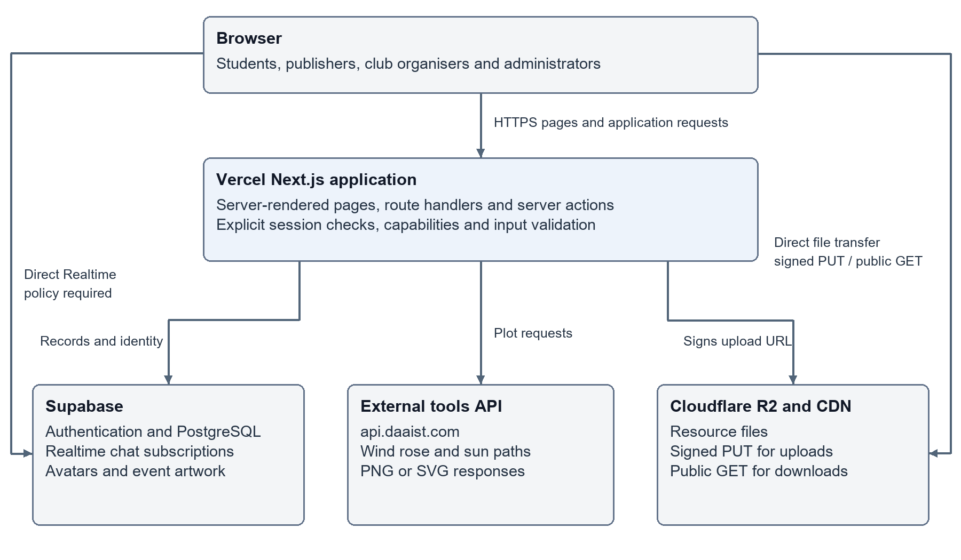
Figure 1. Application architecture and the distinct paths for protected requests, public file delivery and Realtime subscriptions.
Page and API requests reach Next.js over HTTPS. The server issues a short-lived signed PUT URL for authorised uploads. Downloads use public URLs on cdn.daaist.com; possession of a file URL does not require a fresh application session. Chat writes use a checked server action, while subscriptions connect directly to Supabase and require appropriate database and Realtime policies.
React Server Components allow protected pages to check the session before returning their data. Client components handle interactive forms, the scanner, chat and administrative controls.
Next.js route handlers and server actions provide backend operations without a separately maintained API server. Shared helpers define capabilities and validation rules. Protected handlers authenticate and authorise access, but public registration and diagram endpoints intentionally allow anonymous requests with validation and rate limiting.
PostgreSQL fits the relationships between users, files, clubs and registrations. The codebase references the following twelve application tables:
Table 2. Application database domains.
Domain | Tables | Relationship
Identity | profiles, student_enrollments, user_roles, onboarding_status, invites | Profiles and enrolments reference users; roles grant capabilities.
Archive | files, likes | Uploader owns metadata; likes connect users and files.
Clubs | clubs, club_members, events, event_participants | Membership scopes authority; events have registrations and attendance.
Chat | messages | Messages reference an author.
R2 stores learning resources and serves them through the public CDN domain. Supabase Storage holds avatars and club or event artwork. Public file delivery reduces application traffic but cannot enforce private download access on its own.
A configurable api.daaist.com endpoint performs diagram generation outside the Next.js application. Its hosting and capacity are not documented here.

5. Technology choices
The choices favour managed services and a single application codebase. Table 3 lists the main alternative considered for each layer.
Table 3. Technology choices and alternatives.
Layer | Choice | Reason and trade-off | Alternative
Application | Next.js 16, React 19 | One application for pages and server routes. | React SPA and Express
Language | TypeScript 6 | Catches type errors at build time; incoming data is validated separately. | JavaScript
Interface | Tailwind 4 and Radix primitives | Unstyled, reusable controls that fit a custom design. | Material UI
Identity | Supabase Auth with SSR | Handles OAuth and session cookies out of the box. | Auth.js with an adapter
Database | Supabase PostgreSQL | Relational joins and constraints fit memberships and attendance. | Document database
Updates | Supabase Realtime | Live chat updates without running a WebSocket server. | Socket.IO or Pusher
Resources | Cloudflare R2 | Direct uploads and free egress, though storage and requests are billed. | Amazon S3
Images | Supabase Storage | Integration with the existing Supabase project. | R2
Hosting | Vercel | Deploys Next.js with no server setup, at the cost of plan quotas and lock-in. | Render or a VPS
Diagrams | External tools API | Separates plotting from the web runtime; adds an upstream dependency. | In-process generation
Tests | Node test runner | No added framework dependency; framework stubs limit coverage. | Vitest or Jest

6. Implementation
The repository separates pages, request handlers, shared rules and reusable components:
Table 4. Repository organisation.
Location | Responsibility
src/app/(root) | Public and student-facing pages.
src/app/(auth) | Administrative pages and invite redemption.
src/app/api | 36 route-handler files grouped by domain.
src/lib | Shared capabilities, validation, request limits and service clients.
src/components | Feature components and 14 shared UI primitives.
tests | Nine files for behavioural and structural regression tests.
Capability helpers such as canUploadResources(), upload-key validation and participant-pass rules keep repeated decisions in shared modules. This makes selected business rules testable without running the framework. The routes that call these helpers still need their own tests.
For resource publication, PUT /api/upload-url checks the session, publishing capability and request budget. It constructs a key from validated classification and the uploader identity, then issues a five-minute R2 URL with the declared size and stored content type. The browser uploads directly to R2. POST /api/files/create subsequently validates the URL namespace and records metadata. These are separate operations, so a successful object upload followed by a failed metadata request can leave an unlisted object; reconciliation is future work.
Public event registration applies input validation and duplicate handling. A random participant token becomes a QR pass. The check-in route requires a president, vice president or event manager of the relevant club before changing attendance. Each check-in stores a timestamp and method. Scanning the same pass twice does nothing, and an organiser can undo a mistaken check-in. These code paths still need authenticated end-to-end tests against a dedicated test database.
Posting a chat message requires sign-in and the DAA enrolment flag. Messages are capped at 1,000 characters and rate-limited. History is limited to the latest 100 messages. Realtime subscriptions provide updates without an application-owned WebSocket server; their read policies require separate verification.
The diagram routes validate numeric inputs, permitted years and appearance settings before calling the tools API. New tests cover palette and text-colour encoding, light or transparent backgrounds, output preservation and error handling with a mocked upstream. The routes buffer each image in full before returning it.
Metadata, canonical URLs, a sitemap and JSON-LD describe public pages. Protected pages also use crawler directives. These directives only guide crawlers; access control relies on authentication.

7. Security engineering
A remediation branch brings the access checks and upload policy together, with regression tests for both. Table 5 summarises current controls and their limits.
Table 5. Security controls and residual risks.
Area | Current control | Residual consideration
Database clients | Session client uses the anon key; privileged queries use a service-role client. | Service-role operations bypass RLS and require explicit authorisation.
Profile information | Protected profile views and selected response fields. | Check response fields and ownership on every relevant path.
Capabilities | Shared admin and resource-publishing rules. | Global roles and per-club roles must remain separate.
Resource uploads | Server-chosen namespace, declared size limits and stored content type. | No content scanning; public CDN downloads remain shareable.
Event passes | Identity-based pass access and organiser checks for attendance. | Not yet covered by integration tests.
Redirects | Only permitted local return paths. | Any new redirect must be added to the permitted list.
Cookies | Secure in production, SameSite=Lax and configured 30-day retention. | Cookie retention is not a complete session-revocation policy.
Headers | CSP includes script-src 'self' 'unsafe-inline', configured R2 connect-src origins, frame restrictions, HSTS and nosniff. | Inline scripts weaken XSS protection; nonce-based policy is future work.
Abuse controls | 18 rate-limit rules, using account identity where available. | Counters are local to each process.
Errors | Generic client errors for selected failure paths, with server logging. | Operational logs need appropriate access and retention.
The limiter prefers account identity because a campus network may place many students behind one public IP address. Unknown file types are stored as application/octet-stream attachments to reduce inline browser execution. Files are not scanned for malware. The service-role client bypasses row-level security, so every elevated query relies on the server checking permissions first (Supabase, n.d.).

8. Testing and continuous integration
In October 2026, after some fixes, npm test passed all 132 tests across nine files on Node.js 24.18.0. Table 6 breaks them down by file:
Table 6. Automated test coverage.
Test file | Count | Coverage
security-invariants | 38 | Selected source patterns for access control, request limiting and data exposure.
upload-policy | 28 | Key construction, size limits, stored types and image validation.
seo | 18 | Canonical URLs, sitemap and indexing directives.
base-url | 15 | Origin handling and request-limiter behaviour.
profile-validation | 9 | Field validation and conflict messages.
search-filter | 7 | Search input handling and filter construction.
csp | 2 | Configured R2 upload origins and restrictions on executable content.
diagram-appearance | 3 | Theme, palette and text-colour validation.
diagram-routes | 12 | Three handlers: appearance forwarding, defaults, validation and upstream errors.
Structural security tests scan selected source patterns. New diagram-route tests invoke handlers with mocked upstream responses; CSP tests inspect generated directives. These tests stop short of the full Next.js request pipeline and the deployed service policies.
The local .github/workflows/ci.yml defines installation, lint, type checking, tests and a dummy-configured build on Node.js 24 (GitHub, n.d.). However, .gitignore excludes .github and Git does not track this workflow. At the same time, the repository Actions API returned zero runs and the master branch had no .github directory. CI is therefore defined locally but not yet running on GitHub.

9. Deployment and operations
The public application is accessible at https://daaist.com. The site runs on Vercel, with master as the production branch, and uses Cloudflare for file storage and delivery. Master is also the default branch on GitHub. The Vercel deployment dashboard was not checked for this report.
Table 7. Deployment components.
Component | Service | Deployment consideration
Web application | Vercel; production branch master | Build with Next.js; configure server credentials and public variables separately.
Identity and records | Supabase | Auth, PostgreSQL, Realtime and image storage require project configuration.
Resource files | Cloudflare R2 and CDN | Configure the bucket, signed uploads and public delivery domain.
Site diagrams | api.daaist.com | Separate configurable endpoint; infrastructure and operator are not verified here.
The evaluated application revision is 1984ad0, matching the GitHub master head observed in October 2026. Vercel’s deployed commit was not checked. A release record should link the revision, completed checks, deployment URL and dashboard status.
The example environment file documents Supabase, base URLs, tools and R2 configuration. NEXT_PUBLIC_ values can enter browser bundles; service-role and storage credentials must remain server-side. Ignoring .env files reduces accidental commits; obsolete credentials should still be revoked and rotated through their providers.
Database changes are currently applied through the Supabase SQL editor. No versioned schema or migrations are included, so a new environment cannot yet be reproduced from the repository alone.
Persistent application records reside in PostgreSQL and object storage. Vercel can scale application instances within plan and platform limits, while the database, external API and connection budgets may become bottlenecks. R2 internet egress is free, but storage and request operations can still incur charges (Cloudflare, n.d.). Unlike the persistent records in PostgreSQL and object storage, the rate limiter’s counters live in each instance’s memory.

10. Results and evaluation
Evaluation was carried out in October 2026 against local revision 1984ad0 and the public site. Fresh headless Edge sessions checked the homepage, course and document sign-in gates at 1440 × 960, plus the homepage at 390 × 844. All four checks passed. No accounts or production records were changed; authenticated workflows were not exercised.
Table 8. Evaluation observations in October 2026.
Check | Observed result | Interpretation
npm test | 132 passed, 0 failed | Nine test files; includes mocked routes and structural checks.
TypeScript | Passed | Declared types compile without reported errors.
Production build | Passed with dummy service settings | Compilation succeeds; expected fetch errors from inert service URLs.
ESLint | 85 errors and 10 warnings | Quality gate fails; errors affect 26 files.
Public homepage | HTTP 200 and expected heading | Anonymous desktop availability verified.
Course access gate | HTTP 200 with sign-in heading | Anonymous course browsing displays the access gate.
Document access gate | HTTP 200 with sign-in heading | Anonymous document browsing displays the access gate.
Mobile homepage | Expected heading; no horizontal overflow | Limited 390 × 844 layout check, not a full accessibility audit.
Authenticated workflows | Not exercised in this evaluation | Uploads, registration and check-in require separate end-to-end evidence.
Hosted CI | 0 runs; local workflow ignored | GitHub has no hosted run; .github must be published and checks configured.
Figures 2 and 3 were captured during this evaluation. The report includes no user counts, usage over time, user-study results or Lighthouse scores.
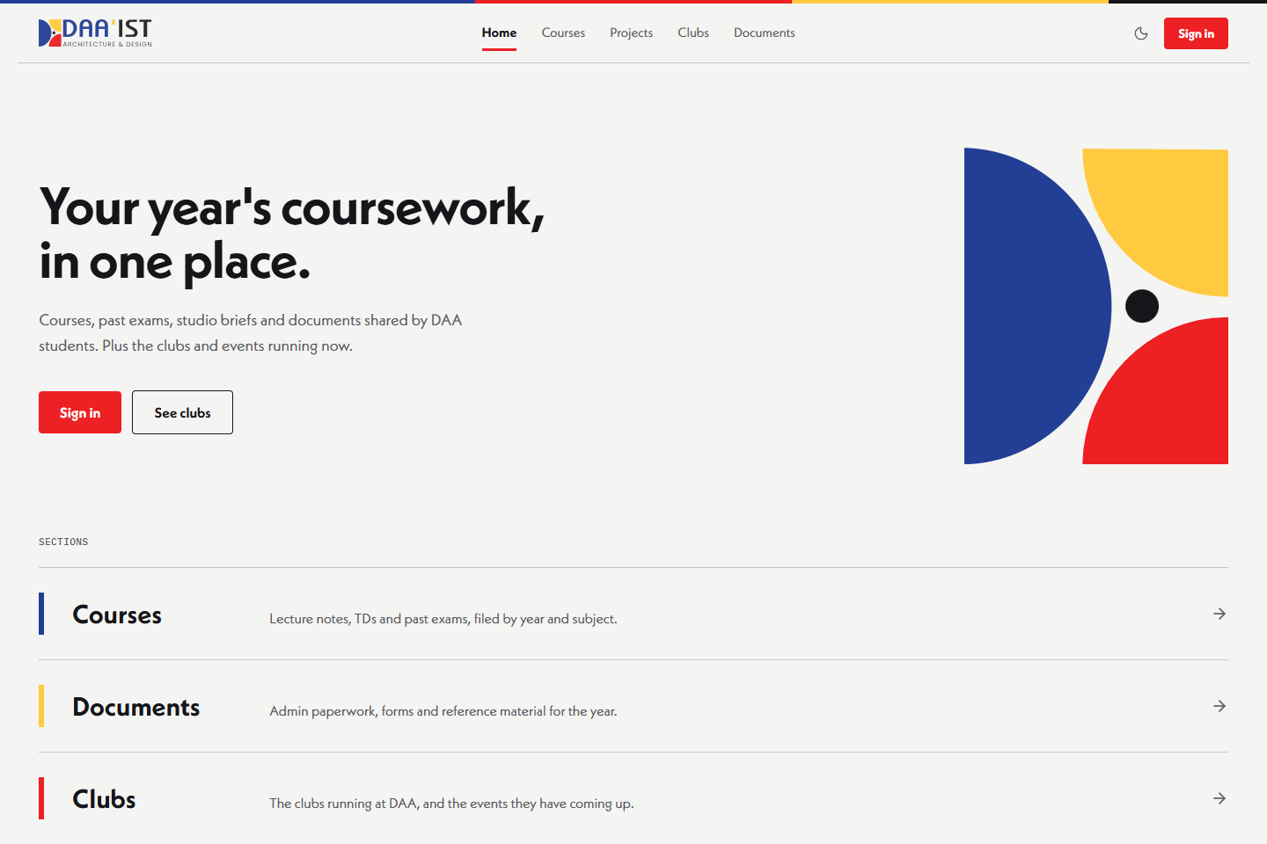
Figure 2. Public homepage captured in October 2026 in a fresh, signed-out browser at 1440 × 960.
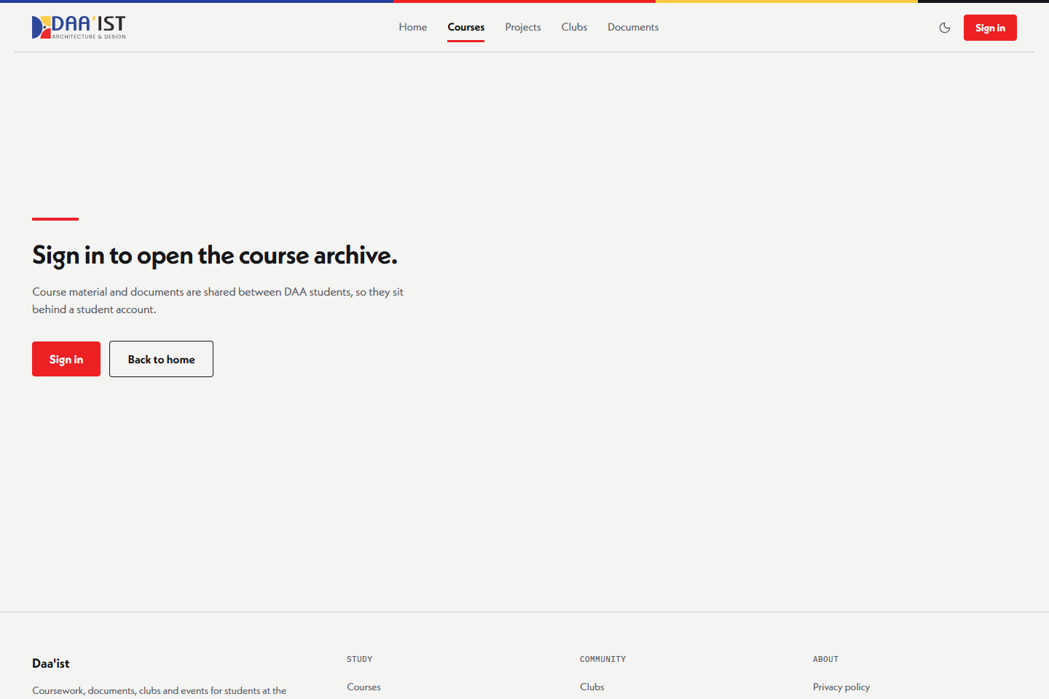
Figure 3. Anonymous access to /courses displays the sign-in gate in October 2026; /docs also passed its separate access-gate check.

11. Limitations and future work
Table 9 lists the main limitations and the next step for each:
Table 9. Limitations and next steps.
Limitation | Impact | Next step
Local request counters | Budgets multiply across instances and reset with process lifecycle. | Use a shared Redis or KV counter if a strict global limit is required.
Inline scripts allowed | CSP provides weaker protection against script injection. | Evaluate nonces with the installed framework version.
Privileged database access | A missed application check can expose records. | Expand session-scoped queries, RLS policies and integration tests.
Public resource URLs | A shared file link can bypass the catalogue sign-in gate. | Define the intended access model; use private storage and authorised downloads if needed.
Schema not versioned | A fresh database cannot be reproduced from the repository alone. | Commit reviewed migrations and test restoration.
Lint failures and unpublished CI | 85 errors remain; the local workflow is ignored and untracked. | Resolve errors, publish the workflow and configure required checks.
Unmeasured user impact and load | Benefits and capacity are unknown, and so are running costs at scale. | Run consented task studies and controlled performance tests.
Projects archive incomplete | Studio projects are not yet available. | Complete only after core workflows and quality issues are addressed.
Priorities are to resolve lint findings, publish the ignored CI workflow, establish a hosted run, version migrations and add authenticated integration tests. Later evaluation should measure retrieval success and time, registration completion, accessibility and load under stated conditions. User studies require consent and minimal personal-data collection.

12. Conclusion
Daa’ist brings official student documents, course resources and club activity into one platform built on managed cloud services. All 132 tests passed in the October 2026 evaluation. The type check, build and four public browser checks also succeeded. Remaining limits include 85 lint errors, an unpublished CI workflow, public file URLs and incomplete runtime evidence. The platform needs user testing and load testing before it can be called production-ready.

References
Baishya, D. and Maheshwari, S. (2020). WhatsApp Groups in Academic Context: Exploring the Academic Uses of WhatsApp Groups among the Students. Contemporary Educational Technology, 11(1), 31–46. https://doi.org/10.30935/cet.641765. Accessed 20 October 2026.
Cloudflare (n.d.). R2 pricing. Documentation. https://developers.cloudflare.com/r2/pricing/. Accessed 20 October 2026.
GitHub (n.d.). Building and testing Node.js. GitHub Actions documentation. https://docs.github.com/en/actions/tutorials/build-and-test-code/nodejs. Accessed 20 October 2026.
le Roux, D. B. and Parry, D. A. (2022). An exploratory investigation of the use and effects of academic instant messaging groups among university students. Education and Information Technologies, 27, 1055–1080. Published online 7 July 2021. https://doi.org/10.1007/s10639-021-10631-y. Accessed 20 October 2026.
Moodle (n.d.). Resources. MoodleDocs. https://docs.moodle.org/en/Resources. Accessed 20 October 2026.
OWASP (2021). A01:2021 Broken Access Control. OWASP Top 10. https://owasp.org/Top10/2021/A01_2021-Broken_Access_Control/. Accessed 20 October 2026.
Safi, L. (2026). E-learning via Moodle Platform in Algerian Universities: An Analytical Study of Use and Practical Challenges from Students’ Perspective. Al-Risala Journal for Media Studies, 9(4), 113–132. https://asjp.cerist.dz/en/article/289325. Accessed 20 October 2026.
Supabase (n.d.). Row Level Security. Documentation. https://supabase.com/docs/guides/database/postgres/row-level-security. Accessed 20 October 2026.
UNESCO (2019). Recommendation on Open Educational Resources (OER). Adopted 25 November 2019. https://www.unesco.org/en/legal-affairs/recommendation-open-educational-resources-oer. Accessed 20 October 2026.

